Goodness of fit – Chapter 13

Enter your observed and expected values going down (one in each column).

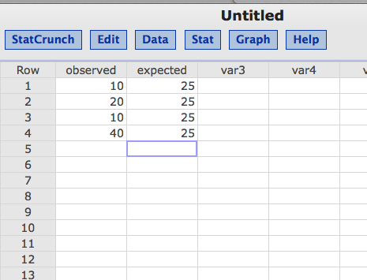

Click stat > goodness of fit > chi-square test.

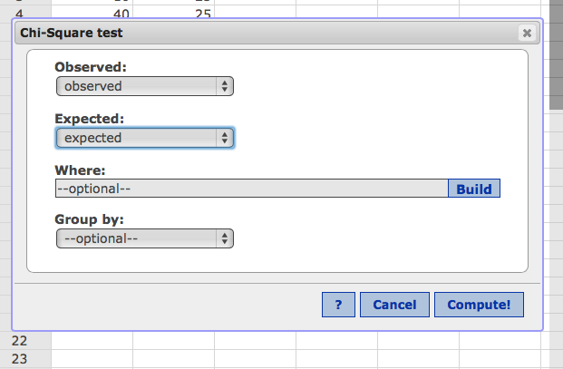

Fill in your observed and expected variables.

Hit calculate.

**Chi-Square goodness-of-fit results:**   
Observed: observed   
Expected: expected

|  |  |  |  |
| --- | --- | --- | --- |
| **N** | **DF** | **Chi-Square** | **P-Value** |
| 80 | 3 | 30 | <0.0001 |

DF = degrees of freedom (step 2).

Chi-square = step 4 X2 value.